Our redevelopment

You will be aware that Clarendon School is being redeveloped on two sites as our current buildings are no longer fit for purpose.
It is proposed that the Clarendon Primary Centre will be in the completely refurbished and extended Newhouse Centre building, in Buckingham Road, Hampton, next door to Buckingham Primary School. The Head of Centre will be Mrs Angela Mason (currently known as Ms Angela Field). Our planning application for the building works was submitted recently, and we envisage that, if both planning and this proposal are approved, the building would be finished and ready to move in to in the Autumn Term of this year.
It is proposed that the Clarendon Secondary Centre will be in a new building on the Richmond College Site, Egerton Road, Twickenham, in the same building as a new secondary school, the Richmond upon Thames School. The Head of Centre will be Mrs Rosemary Clarke. Planning permission has been granted and building is due to start very soon. We envisage that our secondary pupils will be moving into our new premises in September 2018.

The rationale and context

Apart from the obvious benefits to our pupils of being in modern, purpose-built and fully accessible buildings and of the opportunities for inclusion that being adjacent to mainstream schools will bring, the redevelopment also gives us the opportunity to expand and offer more places for young people with complex learning difficulties in the local area.
We are continually working with partner organisations and SEN teams to identify future demand for places at Clarendon. Achieving for Children, the community interest company that provides Children’s Services for Richmond and Kingston Councils, has identified the need for more special school places locally as a matter of urgency. In addition to the significant growth of the general school-aged population in both boroughs, the number of pupils requiring specialist provisions is rising at an even faster rate. Although Clarendon has been over-subscribed for some years, we are still unable to meet the needs of all pupils with complex learning difficulties due to the lack of places, leading to many having longer journey times and being educated further from their home communities.

The proposal

Our proposal is to grow from 108 pupils currently to 148 places by 2018, (with a further 32 places already available at the Gateway Centre, which will remain in their current building, adjacent to Twickenham School).
The proposed Clarendon expansion would eventually provide 52 primary places (currently 32) for pupils aged 4-11, arranged in five classes, and 96 secondary places (currently 76) for pupils aged 11-16, arranged in nine classes.
As an Academy, the expansion proposal will need to be approved by the DfE, and we are therefore seeking the views of parents and other interested parties through this consultation.
We would therefore be very grateful for your response to the questions overleaf, and any other thoughts you might have on this proposal.
Please return the form to the school office.

John Kipps
Executive Headteacher, Clarendon School, and CEO, The Auriga Academy Trust
Clarendon Expansion Consultation:
Please rate the following using:
- Strongly agree
- Agree
- Neither agree nor disagree
- Disagree
- Strongly disagree

More special school places are needed for children and young people with learning difficulties in Richmond and Kingston

More local provision reduces the need for longer journeys and helps children and
young people to play a more active role in their home community

Additional special school places should be available adjacent to mainstream schools to enable more inclusion opportunities when appropriate

Clarendon School has the skills and capacity to offer more places to pupils with learning difficulties without it having a negative impact on their existing pupils

I am in agreement with the proposal to expand Clarendon School

I am in agreement with the proposals to re-locate Clarendon at the Newhouse Centre site (Primary) and at the Richmond College site (Secondary)

My postcode is__________________

Please tick all that apply: I am a
Parent of a Clarendon pupil
Parent of a child with learning difficulties
attending another school
Staff member at Clarendon School
Professional working in schools
Other ________________________
Do you have any other comments about this proposal? If so, please let us know:
Comments:
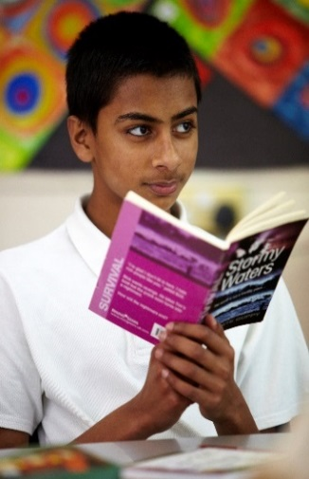
Please return to the school office by Friday 21st April 2017:

Clarendon School, Hanworth Road, Hampton, TW12 3DH
or to jkipps@clarendon.richmond.sch.uk

Clarendon School
Consultation on Proposal
to Expand Pupil Numbers

